NAME:KAVINASHRI V

REG NO:727721EUIT073

SOFTWARE TESTING CC2

YATRA:

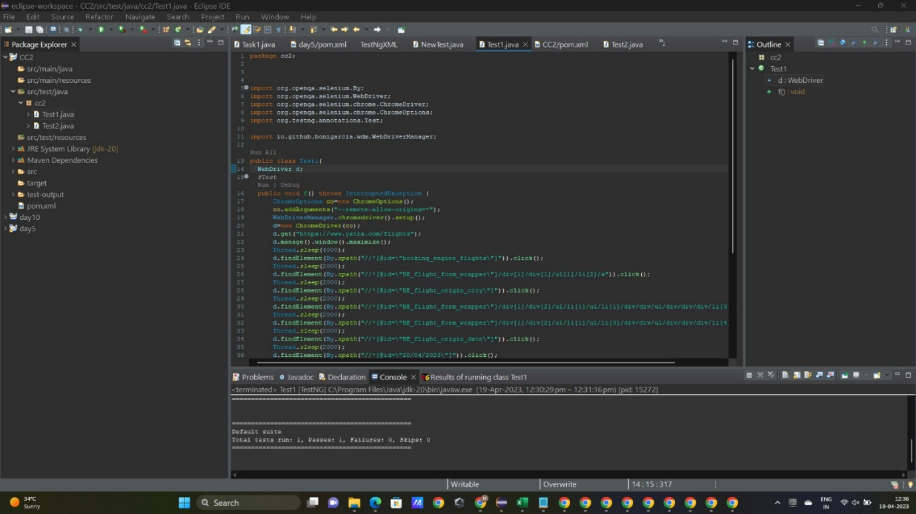



OUTPUT:



